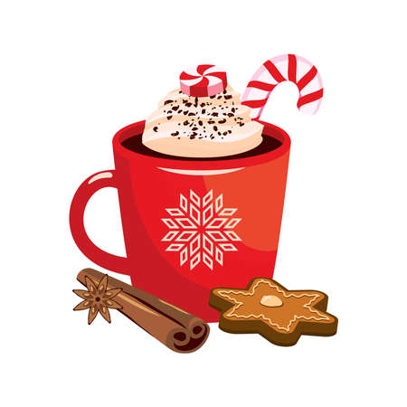
Holiday Cookie Swap
&
Christmas Concert
Dear Parents,
Please join us in our cookie swap/Christmas concert. We ask that each family bring in a plate of homemade cookies (Check with Director which cookies to bring because of food allergies.). We will enjoy swapping cookies, drinking hot cocoa and listening to our kids sing Holiday songs!! Please sign up in the vestibule to let us know if you will be coming and what you will be bringing.
Date: Friday, December 12, 2025
Time: 5:30-7:30 P.M.

