December Newsletter
GiggleBugs Preschool
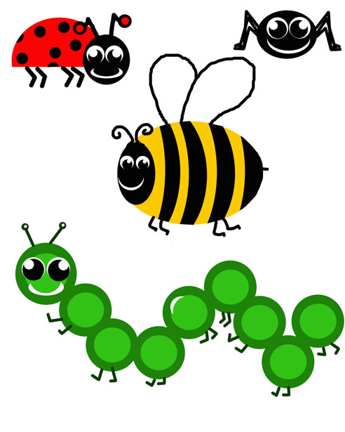Upcoming Events/Special Dates to Remember

December 12
Christmas Cookie Swap/Concert
5:30-7:30pm

December 23

Kids Christmas Party
December 24,25,26
Preschool Closed
January 1
Preschool Closed

LadyBugs Birthdays
Eli
12/17/22

Themes of the Month
12/01-12/05 Forest Animals
12/08-12/12 Baking
12/15-12/19 Holiday Sites/Smells/Sounds
12/22-12/26 Christmas
12/29-01/02 Grocery Store

Themes of the Month

17 Palmer Rd. Monson, MA 01057
Gigglebugspreschoolcenter.com T: (413)267-4373
Greetings Parents,
It is with great pleasure that we welcome you to GiggleBugs Preschool. We have worked hard to get the Preschool ready and we are excited about teaching your children!! I would like to welcome my new staff……….. and staff members I have had the pleasure working with over the past years at my Home Daycare.
At the beginning of every month, you will be receiving a monthly newsletter. Our newsletters will contain upcoming events, reminders and themes of the months for your child’s classroom. Please take the time to transfer important dates to your calendar at home so events will not be missed or forgotten.
During the first month of Preschool the children will be learning classroom routines, meeting new friends and exploring new experiences. We will begin the month with fun activities that will acquaint us with the children and the children with us.
Please wash your child’s hands upon entering the Center!!
Please make sure all of your child’s things are labeled with your child’s name on it so they can be left at school.
If you have any questions/concerns you can always reach out to the Director (Lindsay)!!

Lady Bugs Classroom News
Hello, it’s finally December which it’s almost Christmas! To tart off please remember to send a hat, gloves, coats/snowsuits for your child every day. During the month of December, we have our winter concert/cookie swap on the 12th and Eli’s birthday on the 17th.
The first week we will be learning all about forest animals. The second week of December will be all about baking. We will do baking activities throughout the week, the bakes goods we make will be eaten during afternoon snack!! If you do not want your child to have these snacks please notify either Mrs. Kiara or Miss Emily. The third week will be about Holiday sells/sites/sounds where we can explore all things Christmas. The fourth week will be Christmas week. We will make ornaments for parents and make Christmas crafts. Our last week is grocery week. We will be exploring all the different areas of the grocery store.

Themes of the Month
Red & Green
Christmas
Holiday sites/sounds
Snow

Bumble Bees Birthdays
Madelyn
12/17/24

Themes of the Month
12/01-12/05 Rain Forest
12/08-12/12 Grocery Store
12/15-12/19 Holiday sites/smells/sounds
12/22-12/26 Christmas
12/29-01/02 Zoo Animals

Butterflies Birthdays
Brooks
12/27/23

Miss Emily (LadyBugs Room)
Miss Kiara (Teacher Assistant)

 Bumble Bees Classroom News
December news from the Infant Room:
Hello families! We’re so excited to celebrate the cozy magic of December with your little ones. This month, our themes include red & green, Christmas, Holiday sites & sounds, and snow!!
We’ll explore bright red and green colors through sensory toys, soft scarves, and tummy-time play. Our room will be filled with gentle holiday sights and sounds- twinkly lights, jingles, and soft seasonal music perfect for curious ears. We’ll also enjoy fun snow-themed sensory bins and books as we learn all about winter.
Thank you for sharing your wonderful babies with us. We’re looking forward to a joyful and cozy month together!

- Miss Sarah (BumbleBees Room)
- Miss Jen (Teacher Assistant)

Butterflies Classroom News

SPECIAL MESSAGE
Hello everyone! As it is December I would love if all my kiddos had a hat, gloves, snowsuit, and jacket. Send me a message whether you like me to keep the snowsuit all week or if you’d like me to send them back home every day. Thank you!
The very first week of December, we will be learning about the Rainforest, all the animals, plants, sights and sounds! This week I want to bring in face paint and paint everyone’s face as a different forest animal! Let me know if you do not want your child’s face painted.
The second week we will learn a little about grocery stores, why we have them and of course what’s inside.
The third week we will start our holiday seasons week. There will be a lot of sensory bin play as we will focus on sites, smells and sounds. The week after we have 3 days off! Don’t forget to spread love and cheer! Have a Merry Christmas!!
-Miss Amiya (Butterflies Teacher)
-Miss Ann (Teacher Assistant)

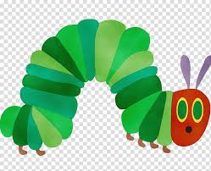

Caterpillars Classroom News
Hello Families!
Welcome to December! My favorite time of year. It’s almost winter, so please bring in a snow suit to keep here, and I can send home at the end of the week or day, whatever you prefer.
The first week will be music week. We will listen to different types of music sounds and musical instruments.
The second week is zoo week. We will learn about zoo animals, what they eat and how they live. We will draw our own zoo with our own animals and learn what different sounds the animals make.
The third week is Holiday sites/sounds/smells week. We will be doing sensory table smells. We will also be having a Christmas cozy day where we play Christmas music while having a tasty snack. We will also make our own music. We will be doing a lot of Christmas projects through out the month as well.
The fourth week we will be learning about emotions and what they are. We will learn to express our feelings in different types of ways, even if we can’t say them. We will be drawing to music of course and we will be singing and dancing to Christmas songs.
Merry Christmas!!
-Mrs. Helen (Caterpillars Teacher)

Themes of the Month
12/01-12/05 Music Week
12/08-12/12 Zoo Animals
12/15-12/19 Holiday Sites/
Smells /Sounds
12/22-12/26 Christmas week
12/29-01/02 Emotions week

Caterpillars Birthdays

No Birthdays

